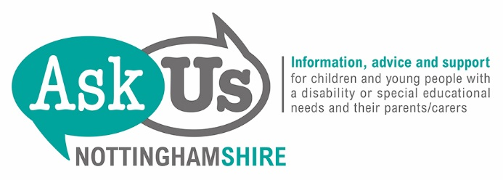

Personal Budgets for SEN

This information is about personal budgets for children and young people with special educational needs who live in Nottinghamshire.

Ask Us Nottinghamshire

Telephone : 08001217772

Email : askus@futuresforyou.com

Post : Ask Us Nottinghamshire,
57 Maid Marian Way,
Nottingham,
NG1 6GE

What is a Personal Budget?

A Personal Budget for SEN is money set aside to fund support as part of an Education, Health and Care plan (EHC plan) for a child or young person with special educational needs. It can include funds from Education, Health and Social Care.

Parents or the young person must always be involved in planning the Personal Budget.

Sometimes the local authority, school or college will look after the Personal Budget for the parents or young person. This is called an Arrangement or a Notional Budget.

Sometimes the parents or the young person may manage all or part of the Personal Budget themselves. The money to do this will come from a Direct Payment.

Sometimes someone else will manage the Personal Budget for the parents or young person. This is called a Third Party Arrangement.

Sometimes the parent or young person will have a mixture of some or all of these arrangements.

Who can have a Personal Budget?

Parents of a child with an EHC plan, or a young person who has an EHC plan, can ask for a Personal Budget. You can also ask for a Personal Budget if your child has been assessed as needing an EHC plan, but this has not yet been finalised. However you do not have to have a Personal Budget.

The SEND Code of Practice (https://www.gov.uk/government/publications/send-code-of-practice-0-to-25) says:

Local authorities must provide information on Personal Budgets as part of the Local Offer. This should include a policy on Personal Budgets that sets out a description of the services across education, health and social care that currently lend themselves to the use of Personal Budgets, how that funding will be made available, and clear and simple statements of eligibility criteria and the decision-making processes. 9.96

A young person with an EHC plan can ask for their own Personal Budget after the end of the school year in which they become 16.

Sometimes the local authority may not agree to a Personal Budget. If that happens the local authority should tell you why.

What can a Personal Budget be used for?

A Personal Budget can be used only on the support set out in an EHC plan. This can include funding for the special educational, health and social care support that will help to achieve the outcomes set out in the Plan.

You can find out what can be included in a Personal Budget in the Local Offer http://www.nottshelpyourself.org.uk/kb5/nottinghamshire/directory/localoffer.page?) You can also ask Ask Us Nottinghamshire (www.askusnotts.org.uk) for more information about this.

A Personal Budget does not cover payment for a place at the school or college, or the general provision for children or young people, including those who need SEN Support. A Personal Budget does include any top up funding (known as Element 3 funding) that is for provision specified in an EHC plan. It can also include support that is managed by the school or college – but only if the Headteacher or Principal agree.

You can find out more about what can be included in a Personal Budget in Sections 9.110 to 9.118 of the SEND Code of Practice.

What is the difference between a Personal Budget and a Direct Payment?

A Personal Budget shows you what money there is to make some of the provision specified in an EHC plan, and who provides it. The parent or young person does not actually manage the funds directly.

With a Direct Payment the parent or young person is given the money for some services and manages the funds themselves. The parent or young person is responsible for buying the service and paying for it.

A Personal Budget can include a Direct Payment if it is agreed that this is the best way to manage part of the Personal Budget.

Direct payments can be used for special educational provision only if the school or college agree.

It is also possible to have a Third Party Arrangement to manage a Direct Payment.

How much will I get if I have Direct Payments?

How much you get will depend on what has been set out in the EHC plan. So it will vary from one person to another.

If the local authority has agreed to make a Direct Payment it must be enough to pay for the service or services specified in the EHC plan.

Are there other kinds of Personal Budget?

Yes – some people have had Personal Budgets for health provision (a Personal Health Budget) and for social care provision (e.g. Fair Access to Short Breaks). They may have managed some or all of the provision using a Direct Payment. But this is the first time that Personal Budgets have become available for SEN provision.

You can find out more about the different kinds of Personal Budget at http://kids.ritdns.com/mip

Where can I get further information, advice or support?

You can see Nottingham City Council’s policy on Personal Budgets http://www.nottshelpyourself.org.uk/kb5/nottinghamshire/directory/results.page?directorychannel=6_2

Ask Us Nottinghamshire can also give you:

- more information about Personal Budgets, including Direct Payments
- advice on whether you may be able to get a Personal Budget and how you can apply for it
- information and advice on local services, organisations, and resources that may be able to help
- information, advice and support on what you can do if you are unhappy with the local authority’s decision on your Personal Budget.

